

**Guidelines for HHC CE for Performance Improvement (PI) Projects**

The American Medical Association defines a Performance Improvement Project as *an activity structured as a three-stage process by which a physician or group of physicians learn about specific performance measures, assess their practice using the selected performance measures, implement interventions to improve performance related to these measures over a useful interval of time, and then reassess their practice using the same performance measures.*

**The CE team is available to assist with planning and documenting your PI project at** [**ContinuingEd@HHCHealth.org**](mailto:ContinuingEd@HHCHealth.org)**.**

# Before Beginning:

* PI CME activities can be done by individual physicians or a group
* All PI CME **must** be structured through CME
  + Participants must be active participants in attendance at a minimum of **50%** of the meetings and work sessions for each stage in order to receive credit for that stage. The Work Group can decide on a higher level of commitment to receive CME.
    - Stage A: 5 Credits
    - Stage A & B: 10 Credits
    - Stage A & B & C: 20 Credits
    - There is no credit awarded to PI participants who complete Stage B or C unless they also participate in Stage A
    - Through reassessment in Stage C, additional needs and issues may be identified. This Stage C can be used as Stage A of a new PI project. Participants in this case will earn 10 credits for completing a new Stage B and C in the new PI project.
* Planners of each PI intervention event may apply for CE credit for learners at that individual event.
  + May include lectures, simulation, journal articles

Stage A: Learning from Current Practice Performance Assessment  
*Assess current practice using the identified performance measures, either through chart reviews or through some other appropriate mechanism.* 

## Step 1: Problem Identification

* Identify an opportunity for improvement
* Must address a facet of the physician’s practice with direct implication for patient care
* Can be identified by system, department, or individual
* Determine team leaders and team members
  + Track attendance at team planning meetings and work sessions

## Step 2: Identify Supporting Data

* Collect benchmark data supporting or informing your goals
  + Minimum of 2 examples
    - Published literature
    - Evidence from other institutions or industry best practice examples (Industry Data)
* Collect local data / metrics
  + Include plan for feasible data collection (i.e. survey, metric query)
* Must measure improvement using the same clearly-identified data before, during, and after PI project
  + Same data
  + Same collection method
  + Same numerators, denominators, and exclusions
* Share identified data with provider team
  + Individual physicians should analyze actual performance data and compare to their perceived performance
  + Providers should determine where they fall within the spectrum of larger populations, such as regional, state and/or national benchmarks
  + Individual physicians need to be involved in analyzing their individual as well as group data to determine where improvements can/should be made

## Step 3: Conduct A3 / Diagnose System Performance

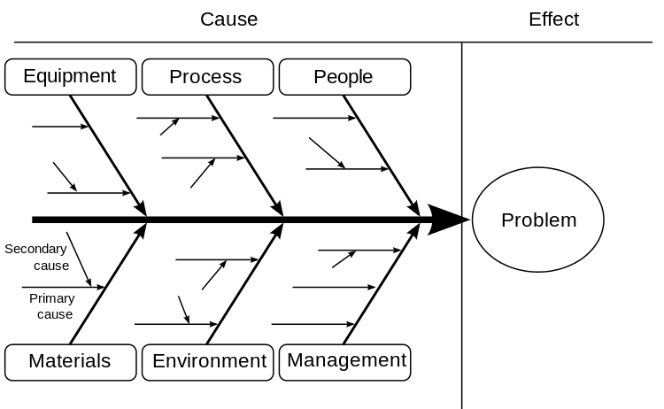

**Fishbone Analysis**

* Complete and Document a Root Cause Analysis
  + - Include colleagues from each level affected
      1. Fishbone 🡪 Cause of Issue as they relate to:
      2. Man (people)
      3. Method (process)
      4. Machine (equipment)
      5. Materials
      6. Measurements (management)
      7. Mother Nature (environment)

1. 5 Whys
   * + - * Ask “**Why**” (**five** is a good rule of thumb) to peel away the layers of symptoms which can lead to the root cause of a problem
         * Should be done for each primary cause
   * Prioritize Root Causes
     + Importance, Urgency, Expansion potential, Ease of completion

* Select Root Causes to address

## Step 4: Objectives and Performance Measures

* Identify the gap type each Root Cause
  + Lack of knowledge
  + Lack of strategies (competence)
  + Lack in performance of provider, group, department
  + --------- patient outcomes
* Identify Learning Objectives for each Root Causes being addressed
  + Create Global Objective
    - Ensure objectives are *SMART* (*S*mart, *M*easureable, *A*chievable, *R*ealistic, *T*imely)
* Write evidence-based Performance Measures based on the gaps and objectives (sample below)
  + No mandated number of performance measures
  + A mechanism that enables the user to quantify the quality of a selected aspect of care by comparing it to a criterion (Institute of Medicine, 2000)
  + Must have direct implication for patient care
  + Pre-written and vetted evidence-based performance measures are available from several organizations for common issues in healthcare
    - Physician Consortium for Performance Improvement [www.physicianconsortium.org](http://www.physicianconsortium.org)
    - National Committee for Quality Assurance [www.ncqa.org](http://www.ncqa.org)
    - National Quality Measures Clearinghouse [www.qualitymeasures.ahrq.gov](http://www.qualitymeasures.ahrq.gov)
    - Physician Quality Reporting Initiative [www.cms.hhs.gov/pqri](http://www.cms.hhs.gov/pqri)
    - Joint Commission [www.jointcommission.org](http://www.jointcommission.org)
  + Include type & description of performance measure from below
    - Structural Performance
      * Measures quality of the physical or organizational aspect of the organization (such as Balanced Scorecard)
    - Process Performance
      * Measures compliance with a specific procedure
      * Actionable feedback
    - Outcome Performance
      * Product quality
      * Is process successful in reaching goal?
  + A fully developed performance measure will have three parts:

1. Numerator Statement = number of patients meeting the numerator criteria (Example: Number of patients in a physician’s practice that received the influenza vaccine)
2. Denominator Statement = number of patients meeting the criteria for numerator inclusion (Example: Number of patients in a physician’s practice that meet the guidelines to receive the influenza vaccine)
3. Denominator Exclusions = patients which should not be included in denominator for several reasons:
   1. Medical reasons/contraindications (Example: Patients that are allergic to eggs and therefore should not receive the influenza vaccine)
   2. Patient reasons (Example: Patients who refuse the influenza vaccine)
   3. System reasons (Example: There is a shortage of the influenza vaccine and it is not available)
   4. These exceptions need to be identified in the medical record
   * Can be reported at several levels
     + Physician level
     + Patient level
     + System level
     + Hospital level
     + Physician group level
     + Payer level
   * Performance Measures should be vetted by CME Department.

**SAMPLE PERFORMANCE MEASURE** [**https://www.cms.gov/Medicare/Quality-Initiatives-Patient-Assessment-Instruments/Hospice-Quality-Reporting/Current-Measures.html**](https://www.cms.gov/Medicare/Quality-Initiatives-Patient-Assessment-Instruments/Hospice-Quality-Reporting/Current-Measures.html)

**NQF #1634 Pain Screening**

|  |  |
| --- | --- |
| **Measure Description:** | Percentage of patient stays during which the patient was screened for pain during the initial nursing assessment. |
| **Numerator Statement:** | Patient stays from the denominator who are screened for the presence or absence of pain and, if present, rating of its severity using a standardized tool within 2 days of admission to hospice. |
| **Denominator Statement:** | All patient stays except for those with exclusions. |
| **Denominator Exclusions:** | Patients are excluded from the denominator if they are under 18 years of age. |
| **Measure Type:** | Process. |

## Step 5: Identify Ideas / Opportunities for Change

* Identify and Choose Change Idea
  + Include:
    - Supporting evidence for change idea
    - Needed or available resources
    - Ease of Implementation
      * Complete any JustDoIts
    - Any new innovations or technology
    - Advantages over Current Process
* Choose Interventions / Countermeasures
  + Collect additional information from colleagues re: ideas for cause or improvement

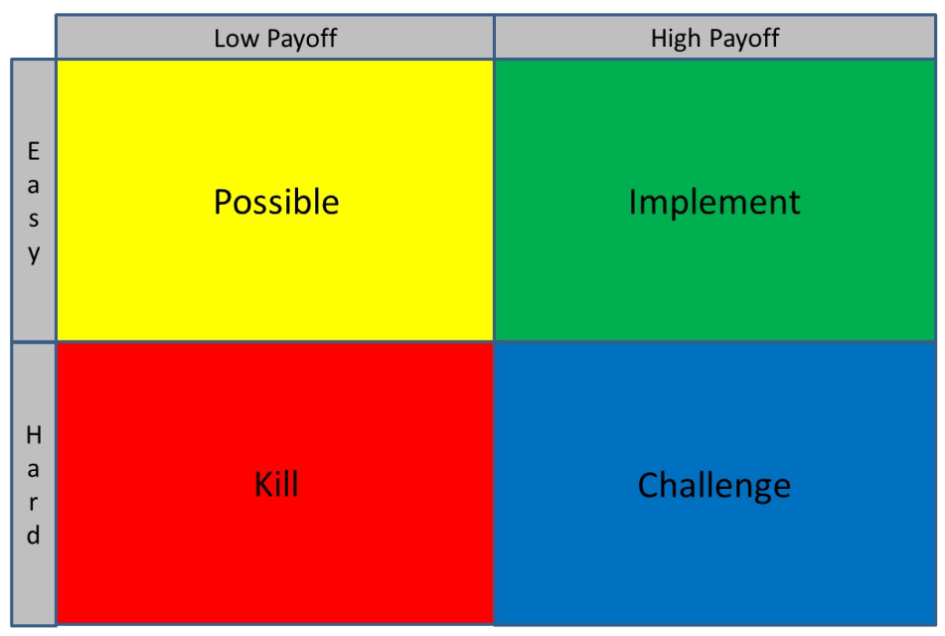

**PICK Chart**

* + Define and Brainstorm Countermeasures
  + Prioritize Countermeasures with a PICK chart 🡪
  + Include:
    - Description of intervention
    - Personnel involved, incl stakeholders & facilitators
    - Scope
    - Scale
    - Real or potential barriers
  + Include a variety of interventions/countermeasures based on type of gaps identified
    - Example: Knowledge Gap 🡪 Education (live class, journal articles, enduring event, emailed reminders)
    - Example: Competence/Strategy Gap 🡪 skills sessions, checklists
* Create a PI Projected Timeline for Stage B and C
  + Stage B is the stage that usually lasts the longest since it requires time to apply the interventions to a sufficient sample size and for a sufficient amount of time in order to be able to evaluate the impact of the intervention(s)
* Complete Stakeholder Management Worksheet
  + Document each stakeholder (individual or group)
    - Level of influence on the project
    - Type of influence
    - Degree or impact of this stakeholder’s influence
    - Strategies to maximize positive stakeholder input and minimize potential disruptions
    - Method of communication with stakeholder
    - Level of Involvement of the Communications/Marketing Department
    - High level needs or wants for the PI project
    - Expectations
* Ensure PI project
  + Identifies the process that needs redesign
  + Defines the data needs and support needed for data management and analysis
  + Identifies and includes all levels of the interprofessional and/or interdisciplinary team
  + Identifies and includes all levels of impacted employees in the process (direct care, housekeeping, registration, lab, etc.)
  + Identifies all economic needs (time, personnel, financial support, etc.)

# Stage B: Learning from the Application of PI to Patient Care

*Implement the intervention(s) based on the results of the analysis, using suitable tracking tools. Participating physicians should receive guidance on appropriate parameters for applying the intervention(s). The time frame for this session is usually the longest of all the stages.*

## Step 6: Implement Interventions for Change

* Implement chosen interventions to your target audience (live education, HealthStream education, journal articles, skills sessions, direct observation and feedback, etc.)

## Step 7: Collecting and Tracking Data

* Use methods and metrics from Stage A to collect and track data throughout Stage B
  + Reassess interventions and readjust as needed
  + Provide and document additional education as needed

# Stage C: Learning from the Evaluation of the PI CME Effort

*Reassess and reflect on performance in practice measured after the implementation of the intervention(s), by comparing to the original assessment and using the same performance measures. Summarize any practice, process, and/or outcome changes that resulted from conducting the PI CME activity.*

## Step 8: Analysis of Improvement

* Collect and review post-event data
  + Use same parameters from Stage A data collection
* Analyze Team Improvement
  + Factors leading to improvement
  + Factors hindering improvement
  + Individual vs team reports
* Include lessons learned from project
* Individual providers should also reflect on their individual improvement using same criteria
* Recommend future steps or improvement plans based on the success or failure of PI project

## Step 9: Share Knowledge and Best Practices (OPTIONAL)

* Provide system-wide or hospital-wide education
  + Other units within facility
  + Other HHC facility’s same unit (i.e., ED to ED, OR to OR)
* Present or publish data