To Locate Activity Event Code for an RSS
- Log in to your account at CloudCME (hhchealth.cloud-cme.com) and click on the Administration option on the bottom left of the page

- Open the RSS Dashboard in the Activities tab
  - Contact continuinged@hhchealth.org if you don’t have access to this option
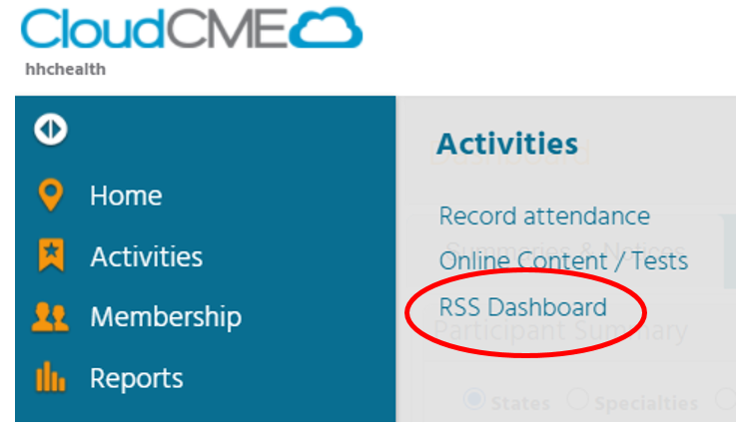
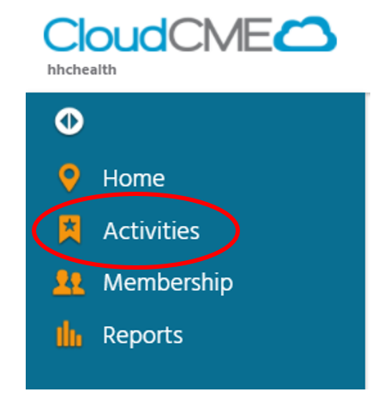

- Locate your specific activity using the search parameters. Uncheck Parents Only.
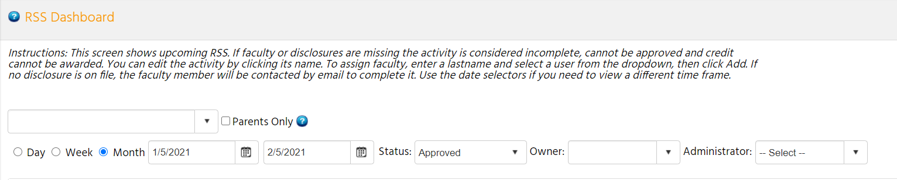

- Locate the specific date in the list. Each session has a different code.

- Copy the Child ID for that date to the Event Code Template.
